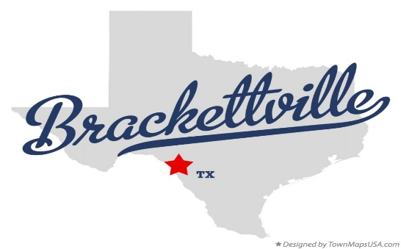
Kinney County Community Park

Master Plan 2021

A 2021 Parks and Recreation Master Plan will be created with community input, including over 100 surveys collected, called in, and analyzed. The community input identified the need to address parks and recreations. The plan will include a 10-year plan to assist Kinney County in current and future parks and recreational areas. The six (6) priorities for park renovation or expansion include:

- Restoration and Expansion of the Baseball Park
- 2 Regulation Fields
- Concession Stand
- Bleachers
- Restrooms
- Expansion of Swimming Pool Area to include a Splash Pad
- Develop Splash Pad with Re-circulation of water
- Pavilion, Landscaping, Lighting , and Walking Track/Trails at the Park Site
- Construct a Pavilion on the Park to bring education programs and families together
- Complete Landscaping with native plants that will develop/enhance natural resources
- Install LED lighting through the park for safety and conservation of energy
- Link the recreational areas within the park with walking trails
- Playground
- Move current playground equipment to the new playground site within the park
- Enhance the playground with equipment that encourages health and fitness
- Multi-Purpose Amphitheater
- Construct a multi-purpose amphitheater within the park
- Bring educational programs on natural resources and conservation
- Soccer Field, Pond and Picnic Area
- Utilize the open space for a Soccer Field
- Construct a pond and picnic area

The Park will be renovated and developed in phases to ensure sustainability throughout the initial 10 years but more importantly for decades to come.

- Adoption of Park Maintenance and Management Plan
- Annual public hearings to address progress and citizen input
- Engagement of stakeholders and promotion of recreational activities
- Improved opportunities for local minority ethnic groups
- Establish/Restore a Park in an underserved area

Vision
The vision of the Parks and Recreation Master Plan is to create a sustainable community-focused park and recreation system. The system will serve all residents, promote a healthy lifestyle, preserve heritage, foster environmental stewardship, and help endorse a sense of community.

